Author: Giorgos Lazaridis
How PC Fans Work (Grammar corrected and condensed from PCB Heaven website)

What is inside a PC fan?

There are many types of PC fans that are assembled in different ways. In this article the basic and most common fan type will be explained. A 3-wire 4 coil 80mm fan rotating at 2200 rpm. Then some other common fans will be explained.
First of all they are not easy to disassemble. You will need some ingenuity and patience:
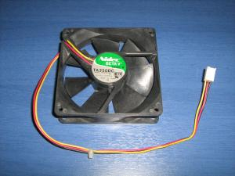 | 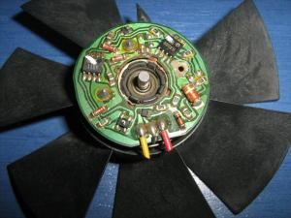 | 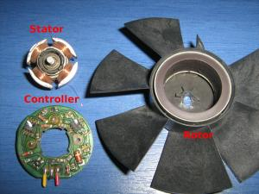
A victim in the name of science | Removing the fins from the housing, the controller is revealed | The rotor, the stator and the controller
It is more than obvious that the PC fan is not rotated from a simple DC motor. It has the permanent magnets fixed on the rotor, the stator carries the coils, there are no brushes and it has a controller for the brushless motor.
Some different PC fan types
There are several reasons that a brushless motor should be used, among them is the reliability, the power efficiency and the rpm feedback. So the motor type would not be the proper way to categorize PC fans. Instead they will be categorized with the most obvious characteristic: their connector or wires.
There are actually 3 different types of PC fans. Those with a 2-pin connector, those with a 3-pin connector and those with a 4-pin connector.
2-wire PC Fans
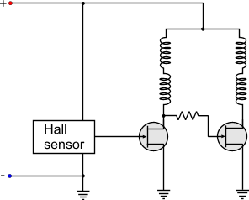
These are the oldest and most simple PC fans. Only two wires come out out of the fan controller, the positive and the negative. Giving power to the fan, it will rotate at full speed. The internal diagram of a typical two-wire fan is as follows:
The connector of a 2-wire fan has a red and a black cable.
The red cable goes to the positive of the power supply and the black to the negative.
Usually, for more flexibility, they have a male-female 4-wire molex power connector.
In one end of the connector the fan is connected in parallel with the 12V (YELLOW - BLACK). Therefore, the fan is powered normally and the cable of the PSU can be used to power another device.
3-wire PC Fans A very common type of PC fan. These fans introduced the "tacho" for the first time. The first two wires are the power supply of the fan. The third wire, comes directly from the output of the Hall sensor. This output generates 2 pulses per one revolution of a fan. The fan is then connected to the motherboard. From the third wire, the motherboard can "read" the tacho of the fan and see if the fan is running at how many RPM. If the motherboard sees no pulses or very low rpm, then the characteristic buzzer sounds to inform the operator that something is not ok. The internal diagram of a typical three-wire fan is as follows:
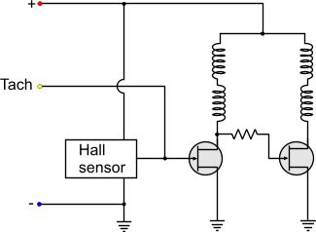
It seems that for once more, the manufacturers did not have the same wire provider, or their wire providers did not have the same colored-plastic provider... Two fans with 3-wire connectors may not have the same wire colors. Thus, instead of using the colors to distinguish the function, better go with the connector that is standard. No matter what color the cable has, it will be plugged in the same motherboard connector! So,as you look from the key-side of the connector, number 1 is the most left pin:
- 1: Negative power supply (black)
- 2: Positive power supply
- 3: Tacho

4-wire PC Fans This is the most modern type of PC fan. This fan is designed to be controlled with a PWM signal to regulate its speed. All fans actually can be controlled with PWM, but this particular type can also provide tacho feedback simultaneously, something that the 3-wire fan cannot do under normal circumstances. The controller and the Hall sensor are always fed with constant current. A transistor (FET) is placed before the coils. The gate of the transistor is actually the fourth wire. So, the PWM pulses are driving the transistor. The coils receive these pulses through the transistor, but the controller along with the Hall sensor are not affected at all. This change can be seen in the internal diagram of a typical 4-wire fan:
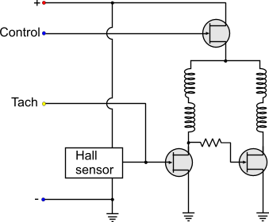
Usually, the diagram is more complicated than this but gives an idea about the principle of operation of PC PWM fans. The controller actually checks the PWM input pulses and sends pulses to the transistor accordingly. If the PWM duty cycle is bellow a threshold value, then the fan either shuts down, or it remains in a stable 'LOW" rpm. Some types even keep running with 0% duty cycle. This is usually done by special design in critical applications. As for the pinout. Just do not trust the colors. As you look from the key-side of the connector, number 1 is the most left:
- 1: Negative power supply (black)
- 2: Positive power supply
- 3: Tacho
- 4: PWM control
Can I connect a 3-wire fan to a 4-wire connector? Yes you can. If you notice the pinout of the fans, the 3 first pins are the same for the 3 and 4 wire fans. Also, the keys are the same for both connectors. The 4-wire connector has smaller back-key to accept the smaller 3-wire fan connector keys. The fan will always run at full speed (as the control pin will not be used), but the rpm feedback (tacho) of the fan will operate normally and the motherboard will read the rpm normally.
Can I connect a 4-wire fan to a 3-wire connector?
Yes you can but the connector is larger, The keys of the 4-wire fan have the same distance as the 3-wire connector. The The fan will operate at full speed all the time, as the 4th wire from the PWM control will be on air. The motherboard will normally read the rpm feedback from the fan tacho.

